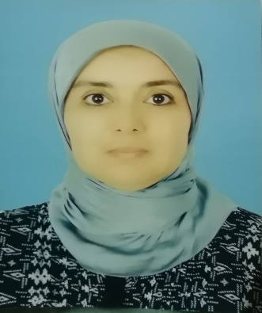

**Workshop 3 :**

**Work Ethics : A Vital Soft Skill for a Successful Profesional Business**



**Pr Asmae ACHEHBAR**

ENSA, USMBA, Fès



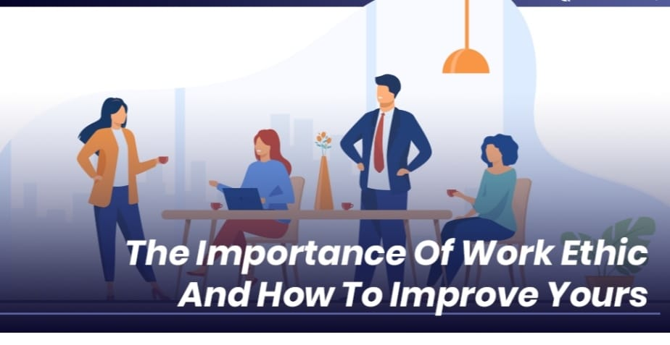

The objective of this workshop is to make the student engineer aware of the importance of work ethics in the successful integration of the employee and the development of his/her professional career, especially in terms of :

* Self motivation and adaptability,
* Integrity and teamwork,
* Honesty, reliability and commitment,
* Discipline, determination and time management,
* Responsability and professionalim.

Mots clés : Work Ethics, soft-skill, sucessful profesional business, professional career, professional. effectiveness, operational performance.



**ENSAF**

**JEPI#2**



## JEPI#2 : *Un futur ingénieur, déjà entrepreneur*